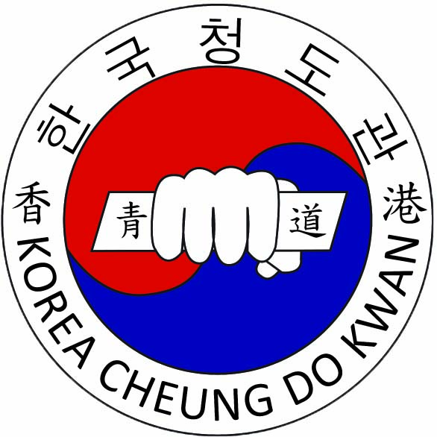
KOREA TAEKWONDO CHEUNG DO KWAN LTD.
HIRING: OFFICE SECRETARY who doesn’t hate children ;)

Job Information:
Office Secretary for the largest Korean Taekwondo School in Hong Kong!
Duties:
Receiving payment, bookkeeping, receiving phone calls, checking inventory and student attendance and any other related deskwork. Our secretary is the face of our school so this job requires excellent customer service to our students and parents. You will also have a great Korean Taekwondo Master working with you in your team.
Company Information:
We are the leading Korean Taekwondo School in Hong Kong with the goal to teach Taekwondo in its original state of martial art. We plan to continuously teach and produce kickass Black belts who are respected not only for their skills but their discipline and manner. We will always be ethical, honest and fair to all our staff and student and treat our people like family.
Qualifications:
Must be friendly and possess excellent communication and customer service skills.
Must know English and Cantonese
High School Graduate in Hong Kong
Hours of work: Monday, Wednesday to Sunday (can be flexible)
Date needed: June 1st, 2016
Working Hours (flexible): ~ 3 to 4 hours per weekday and 10am to 5pm on Saturday
Location: Hong Kong Island, Hong Kong (discussed through e-mail)
Base Pay: Discussed through interview
Contact (for more details): Email: cdktaekwon@gmail.com

